JEREMIAH NYAGAH NATIONAL POLYTECHNIC

ELECTRICAL AND ELECTRONICS DEPARTMENT
AUTOMATE AN ELECTRICAL MACHINE

PRACTICAL ASSESSMENT I

50 MARKS

Qualification Code: 071306T4EEN
Qualification: Electrical Engineering Level 6
Unit Code: ENG/OS/PO/CR/05/6
Unit of Competency: Automate an Electrical Machine

INSTRUCTIONS TO THE CANDIDATE
- Time Allocated: 3 hours.
- Use provided materials only.
- Comply with I.E.E regulations.
- Assessor will record critical steps via audio-visual means.

Resources Provided:
- PLC (1)
- Conveyor motor (M1)
- Clamping solenoid (SOL1)
- Drill motor (M2)
- Linear actuator for drill movement (M3)
- Limit switches (LS1: workpiece position, LS2: drill fully raised, LS3: drill fully lowered)
- Thermal overload sensor (OL1)
- Red indicator light (L1)
- Start (NO) and Stop (NC) push buttons
- 4.0 mm² & 1.5 mm² PVC cables
- Mini-trunking, multimeter, tools

Problem: Automated Drilling Machine
System Requirements:
- Cycle Start:
  - Press Start PB → Conveyor (M1) moves workpiece into position (detected by LS1).
  - Stop M1 → Clamp workpiece (SOL1 activates).
  - Start drill motor (M2) → Lower drill (M3 extends until LS3).
- Safety:
  - If thermal overload (OL1) occurs:
    - Immediately stop all motors.
    - Turn on red light (L1).
- Cycle Completion:
  - Retract drill (M3 retracts until LS2) → Stop drill motor (M2) → Unclamp (SOL1 deactivates).
  - Repeat for next workpiece until Stop PB is pressed.

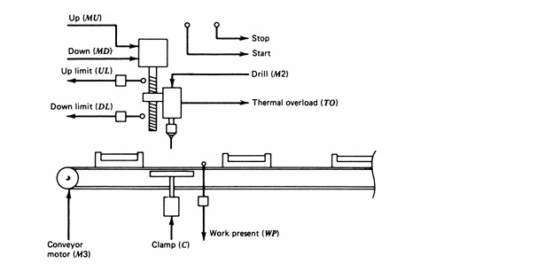
Figure

TASKS

TASK 1: Design (7 Marks)
- Draw:
  - Block diagram (PLC, sensors, actuators).
  - Wiring diagram (Include power supply, I/O connections, emergency light circuit).

TASK 2: PLC Programming (15 Marks)
- Write ladder logic to:
  - Implement the drilling cycle with Start/Stop control.
  - Integrate thermal overload protection (OL1 → L1 + halt).
  - Use limit switches (LS1-LS3) for position feedback.
- Label operands.

TASK 3: Simulation (10 Marks)
- Simulate using software (e.g., TIA Portal) to verify:
  - Drill movement sequence (extend/retract).
  - Overload response (L1 activation).

TASK 4: Hardware Installation (10 Marks)
- Mount components on the board.
- Wire neatly with color coding (e.g., red for power, black for grounds).

TASK 5: Testing (8 Marks)
- Download program to PLC.
- Test:
  - Full drilling cycle (1 workpiece).
  - Overload simulation (trigger OL1 → check L1 and motor halt).

